CL 32
ELECTRONIC PATIENT CARE BED, 3 MOTORS
- Electrical operated backrest, height and legrest adjustment
- Fowler and Vascular positions
- Hand remote control
- Detachable PP head and foot boards
- Auto-contour
- Easily cleanable, lockable and fold-away PP side rails
- Auto-regression system for backrest
- Easy removable ABS mattress platform
- Angle indicator for backrest
- Electrostatic powder coated metal frame
- Footrest adjustment by ratchet
- Height adjustable IV pole
- Protective plastic corner bumpers
- 125 mm diagonal lockable castors
- 125 mm central lockable castors (optional)
- Dual side manual CPR levers at backrest (optional)
- Bed Extension (optional)
- Battery backup (optional)
- IPX6 standard electronic system
 | TECHNICAL DETAILS
 | Overall Length | : 220 cm
 | Overall Width | : 100 cm
 | Mattress Surface | : 85 x 200 cm
 | Height | : 42-81 cm
 | Backrest Angle | : 0°-70°
 | Legrest Angle | : 0°-40°
 | Castor Diameter | : 12,5 cm
 | Under bed Clearance | : 12,5 cm
 | Safe Working Load | : 250 kg

 | ELECTRICAL DATA
 | Power In | : 1.5A max. At 230V AC 50-60 Hz
 | Electrical Shock Protection | : Class I, Type B
 | Liquid Ingress Protection | : IPX6

OPTIONAL ACCESSORIES
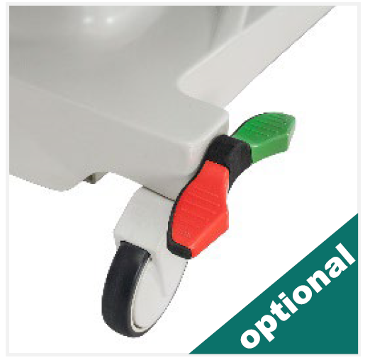
Central Brake Castors, 150 mm
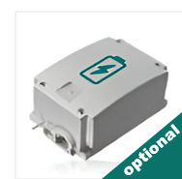
Rechargeable Battery Backup

Trendelenburg by Gas Spring
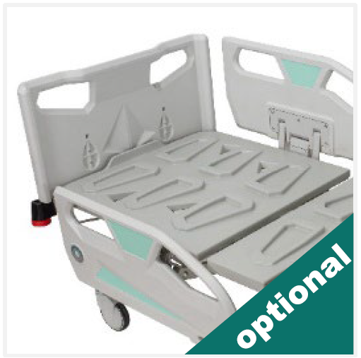
X-Ray Cassette Holder at Backrest
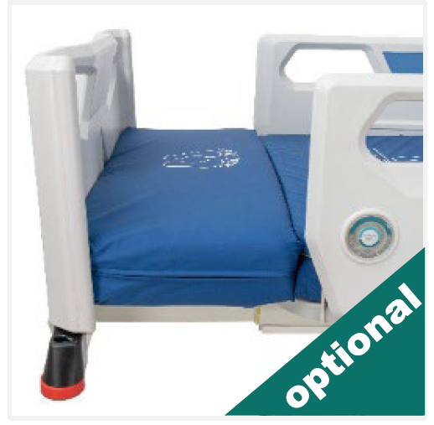
Bed Extension
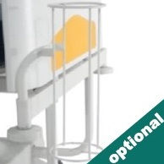
Oxygen Cylinder Holder
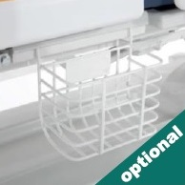
Urine Bag Basket
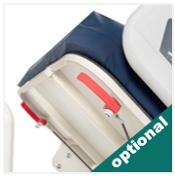
Dual Sided Manual CPR at Backrest
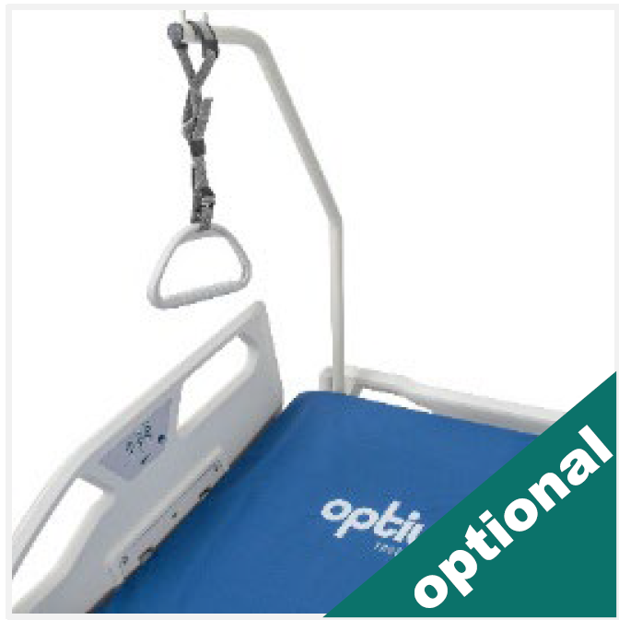
Lifting Pole
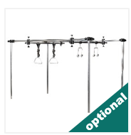
Orthopedic Traction System
COLOR CHART
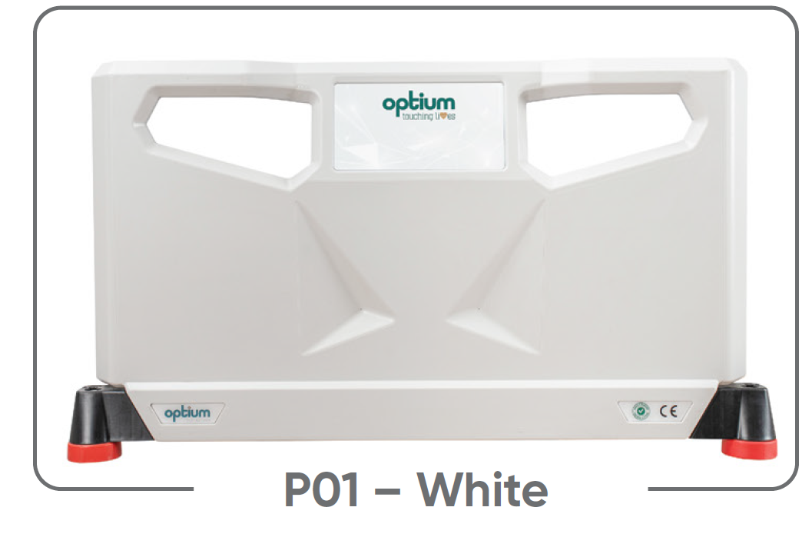
P01 – White
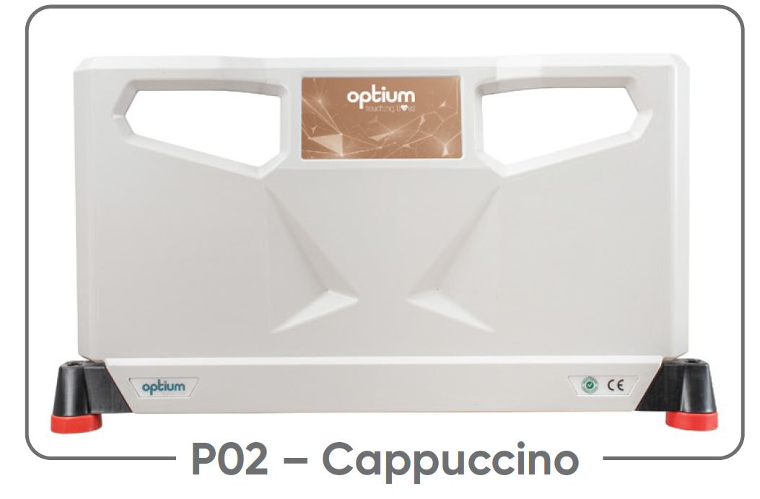
P02 – Cappuccino
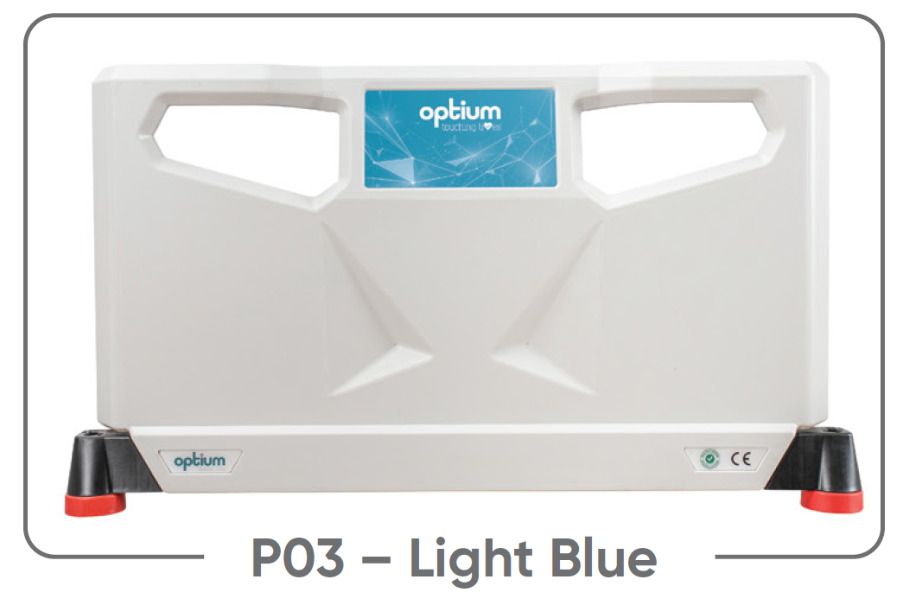
P03 – Light Blue
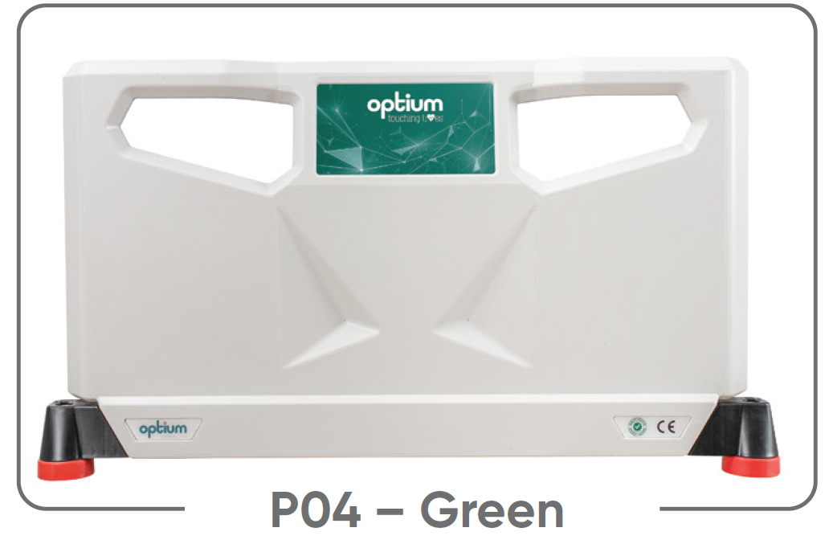
P04 – Green
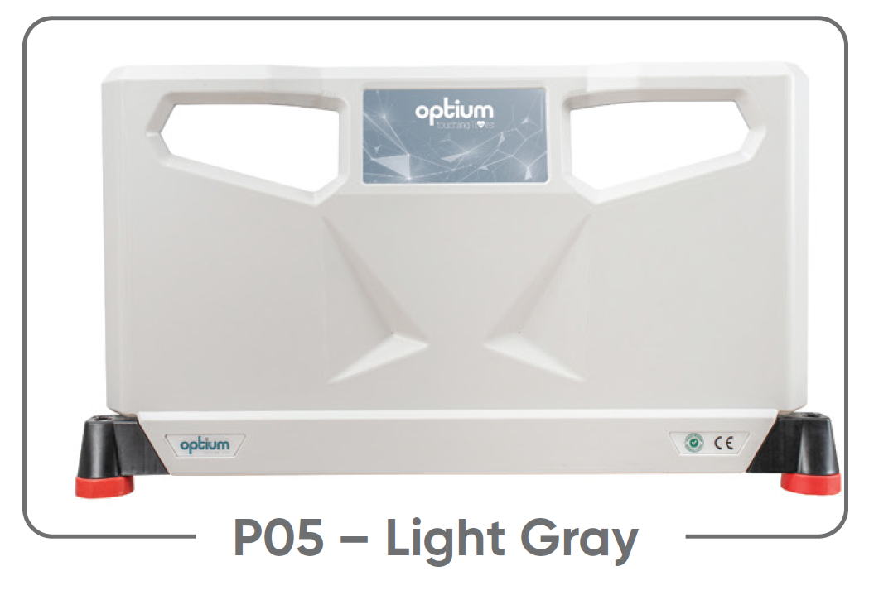
P05 – Light Gray
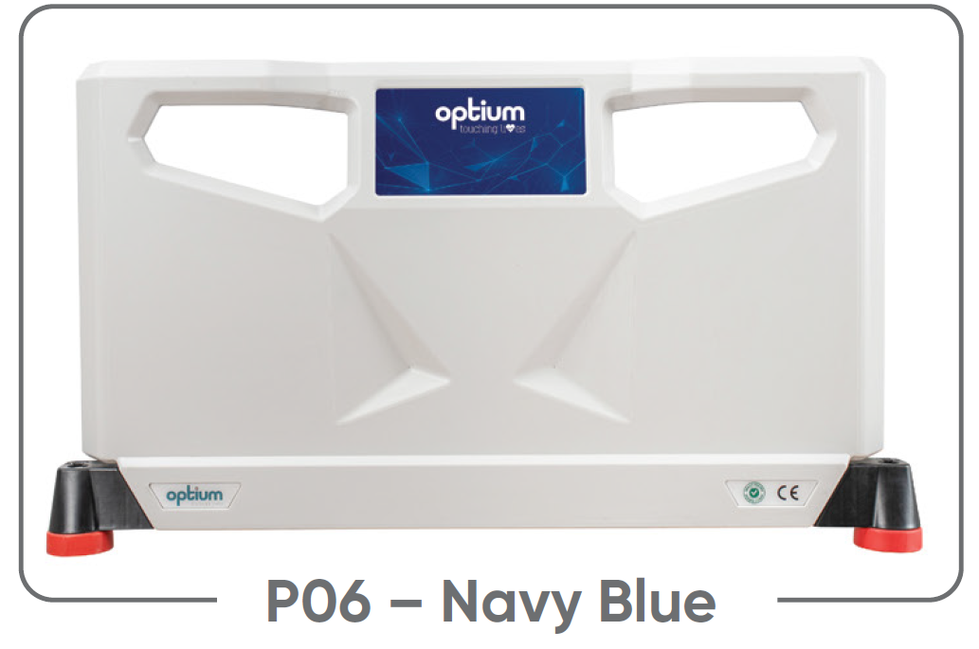
P06 – Navy Blue
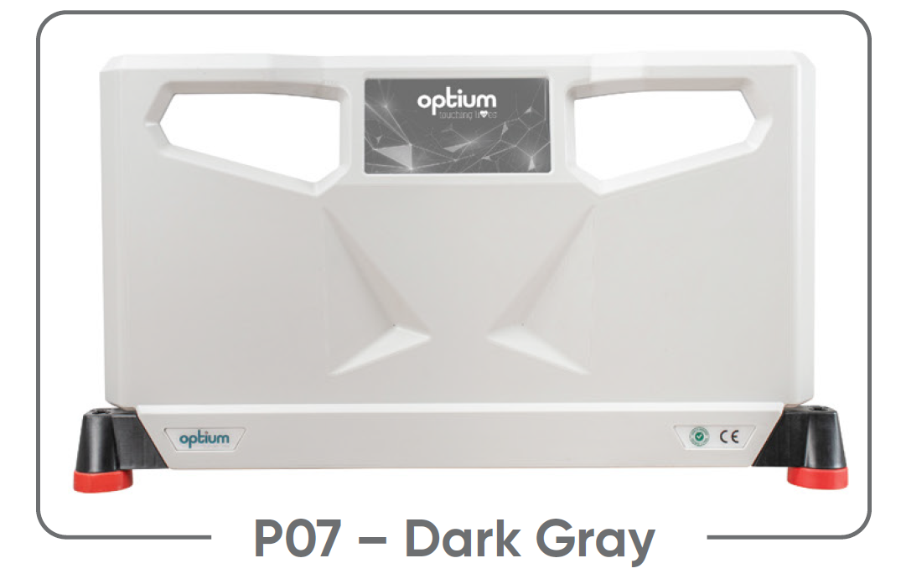
P07 – Dark Gray
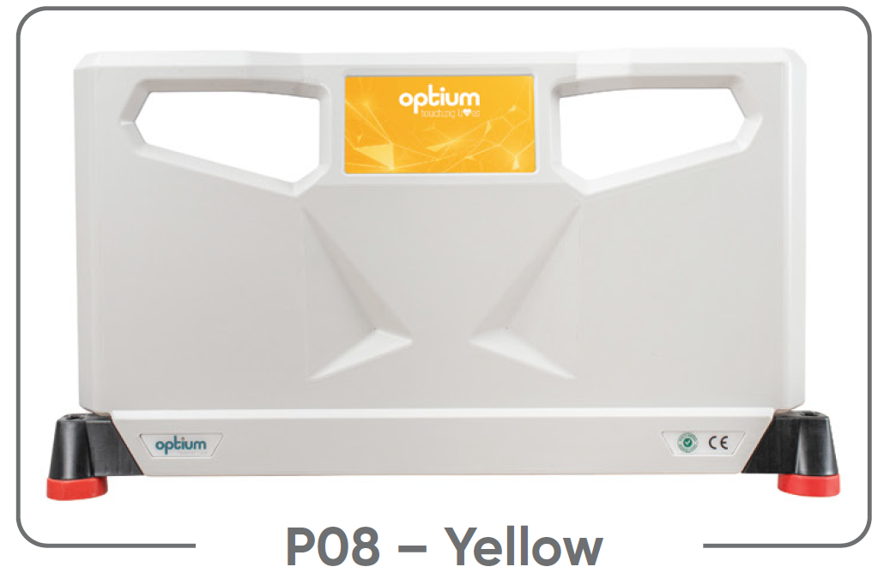
P08 – Yellow
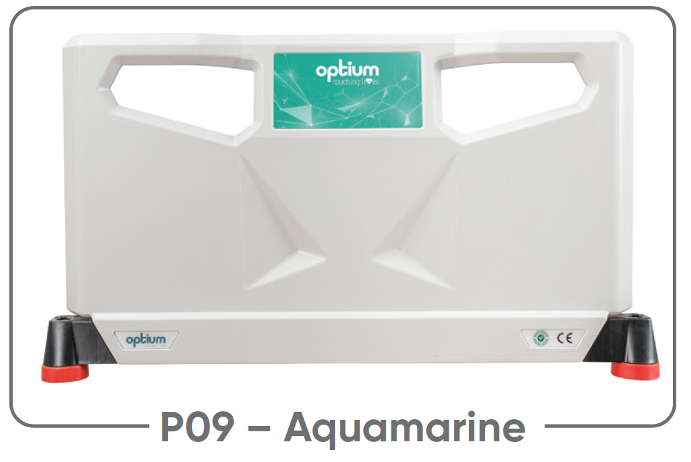
P09 – Aquamarine
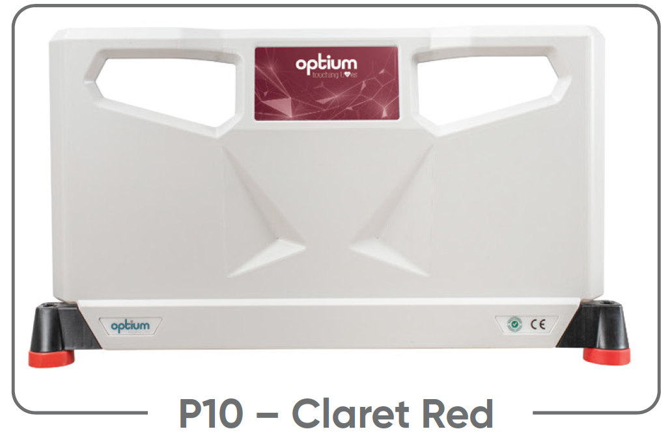
P10 – Claret Red

